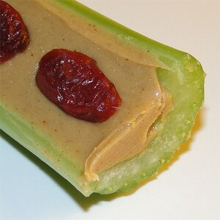

**Red Ants on a Log**

**Ingredients:**

1 tablespoon peanut butter

1 stalk celery

10 dried cranberries

**Directions:**

1. Spread the peanut butter onto the hollow part of the celery. Arrange the cranberries in a line on top of the peanut butter.

**Nutrition Facts (Per Serving)**

Calories 132 Prep: 5 minutes

Protein 4.4 g (9% DV) Total: 5 minutes

Carbohydrates 12.6 g (4% DV) Servings: 1

Fat 8.3 g (13% DV) Yield: 1 log

Cholesterol 0 mg

Sodium 106.6 mg (4% DV)